**Daily and Hourly Editor**

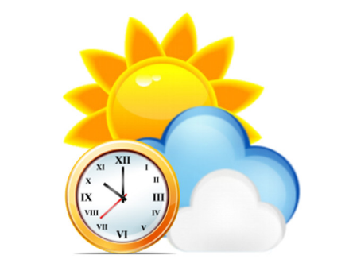

**Jacques Régnière**

**Rémi Saint-Amant**

**Ariane Béchard**

**Ahmed Moutaoufik**

**2017**

**Natural Resources Canada**

**Canadian Forest Service**

**Laurentian Forestry Centre**

**P.O. Box 10380, Stn. Sainte-Foy**

**Quebec, QC Canada, G1V 4C7**

Table of Contents

1. Daily/Hourly Database 7

1.1. Introduction 7

1.2. Daily/Hourly Editor Application 7

1.2.1. Station list Windows 9

1.2.2. Properties Windows 9

1.2.3. Spreadsheet Windows 10

1.2.4. Graphics Window 11

1.3. Hourly Data 12

1.4. Example 12

1. Daily/Hourly Database

## Introduction

Daily/Hourly databases are used to run BioSIM simulations in historical or real time, meaning from daily/hourly weather records rather than from randomized normals. Key applications of this usage are: simulating the past occurrence of weather-driven events using past weather records, or forecasting them into the near-future (e.g. seasonal) using the most current weather records. Near-future forecasting requires a Daily/Hourly database that is as up to date as possible to provide the most recent data available. Updating near-future forecasts implies the maintenance (update) of Daily/Hourly databases.

A Daily/Hourly database is composed of a metadata file (.DailyDB/.HourlyDB), a stations definition file (.DailyHdr.csv/.HourlyHdr.csv) listing the available daily/Hourly weather stations and references to the Daily/Hourly data files (.csv) that contain the actual daily/hourly weather records and that are stored in a separate sub-directory. This sub-directory bears the same name as the metadata file plus the letter H for hourly and D for daily database. Some optimisation files are automatically created and updated by BioSIM.

NOTE: When available, weather forecasts can be added directly in the data files.

## Daily/Hourly Editor Application

Daily/Hourly databases can be opened in the Daily/Hourly Editor application.

The Daily/Hourly Database Editor application can be accessed by selecting [Tools] [Daily/Hourly Editor…] from the menu bar, or by clicking the Daily Editor button  or the Hourly Editor button on the main window’s toolbar.

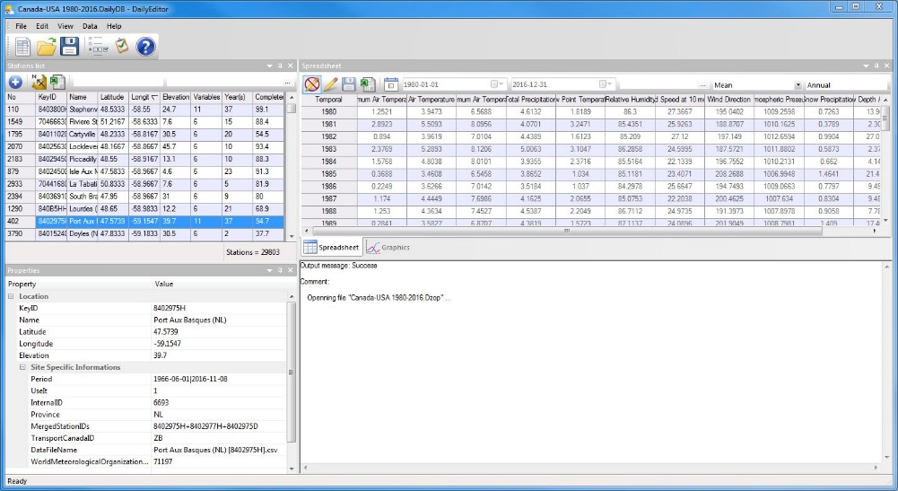

The Daily/Hourly Editor consists of four window: Stations list, Properties, Spreadsheet, and Graphics.

Buttons available in the Daily/Hourly Editor application are as follows:

The New button  can be used to create a new database.

The Open button  in this field can be used to browse for and open database in the Editor.

The Save button  can be used to save the changes on the active database.

### Station list Windows

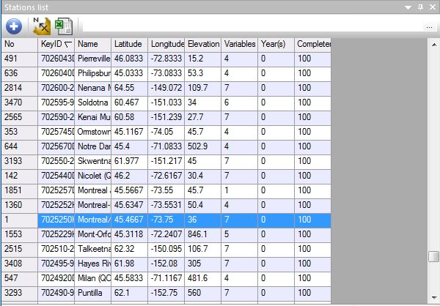This window allows you to view all weather stations in the database and allows adding new stations.

This window offers the following buttons:

 Add: Add a new station to the list of stations in the database

 Send to ShowMap: Display the location of all the stations listed in the database in the ShowMap application.

Send to Excel: Sends the coordinates of all the stations listed in the database to the spreadsheet software Excel the user previously specified in the *Links* page of the Options dialog.

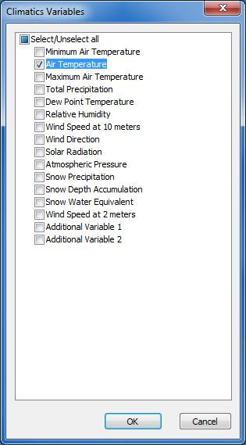

**Year Filter** field**:** A filter allowing the user to view the stations by year. When used, the main list field of the Editor dialog will only show the stations that have data for the specified year. If a selection has also been made in the **Variables Filter** field, the stations shown in the list field will take both filters into account.

**Variables Filter** field (browse button …)**:** Select filters to apply to the list of stations. You can choose from several Climatic variables.

If all filters are unchecked Décocher, every station available in the database will be displayed in the list field. If two or more filters are checked Cocher, only the stations that have information on each data type selected will be displayed in the list field.

### Properties Windows

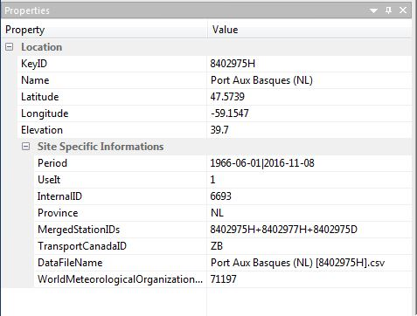This window allows viewing the properties of the selected weather station such as the location (KeyID, Name, Latitude, Longitude, and Elevation), Besides the Site Specific Information (UseIt, Period, MergedStationIDs, State…).

### Spreadsheet Windows

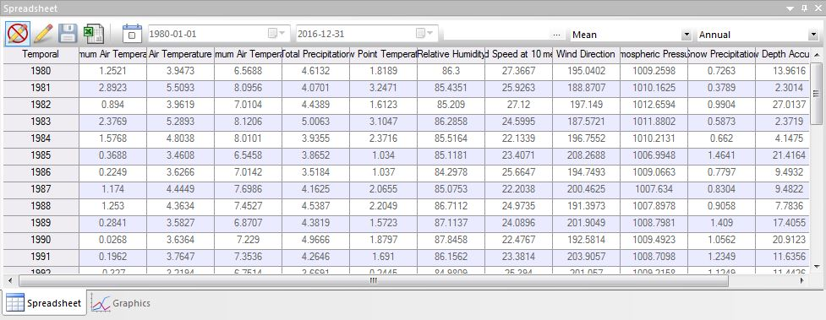This window allows to display by using the Visualisation Mode button  or to modify the data about a weather station by using the Edit Mode button.

Buttons in this dialog are as follows:

**Visualisation Mode**  button: allow just visualizing the weather data of the selected station player, either to save modification and seesaw in the mode visualization.

This **Edit Mode** button  used to activate modify data on a weather station. All fields in the Normals Station Editor are editable.

**Save weather data**  button: save the modifications, without seesaw in the mode visualization.

**Send to Excel**  button: Sends weather data from the selected station to the Excel spreadsheet.

**Period**  button: used / unused user define period filter.

**Begin ** filed: used to select begin date for period filter.

**End ** filed: used to select end date for period filter.

**Variables Filter** field (browse button …)**:** Select filters to apply to the weather data. You can choose from several Climatic variables.

**Temporal Type** field: used to select temporal type (annual, monthly or daily) of weather data to display.

### Graphics Window

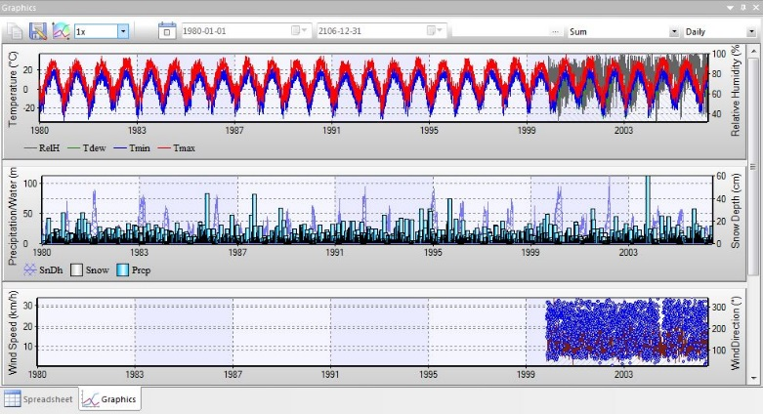This Graphics window, which allows the user to view a graph of the station’s weather data (one graph for each type of weather data).

Buttons in this dialog are as follows:

Copy Graphics  button: Use to copy the graphics in press-paper for uses it later.

Save Graphics  button: Use to save the graphs of the station selected in the 'JPEG' images.

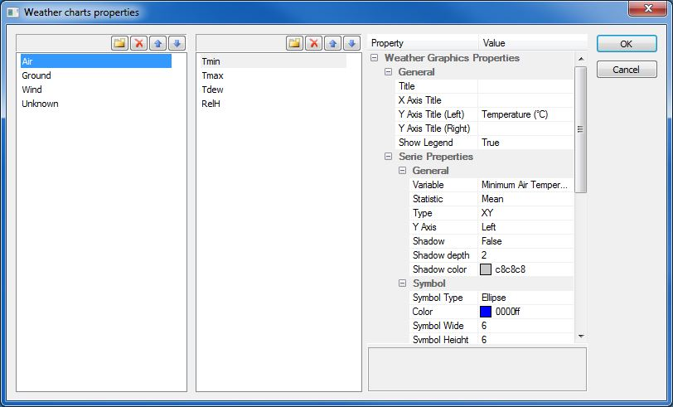Define Graphics Options  button: Used to define climatic variables and the various graphic options.

## Hourly Data

Hourly data file have exactly the same structure as the daily data file but have an extra Hour column.

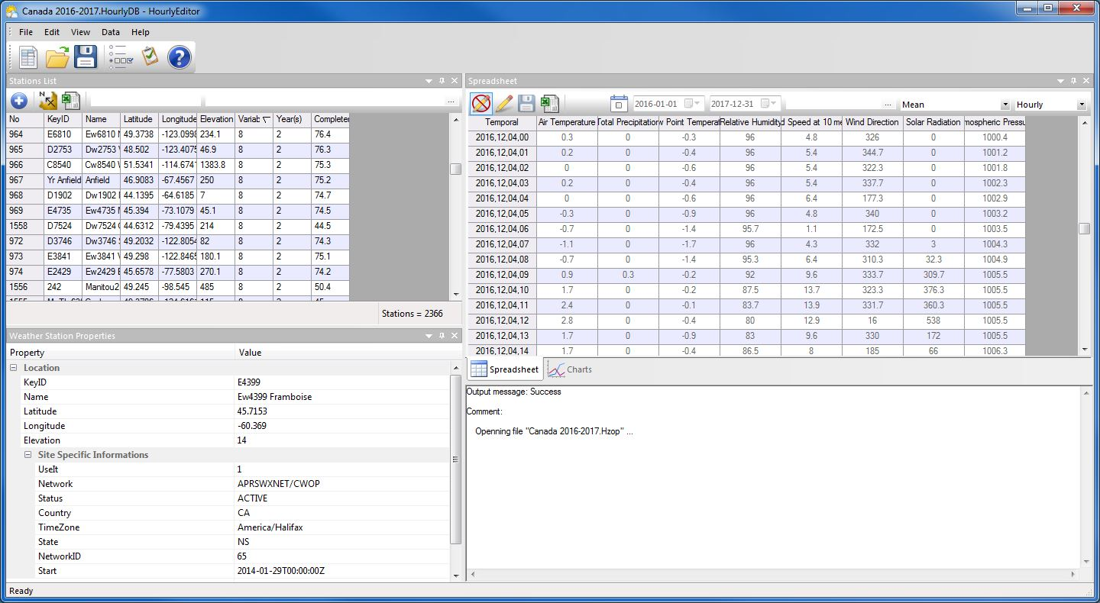

The Hourly Editor application is similar to Daily Editor application

## Example

Many example can be find here:

ftp://ftp.cfl.scf.rncan.gc.ca/regniere/Data11/Weather/Daily/

ftp://ftp.cfl.scf.rncan.gc.ca/regniere/Data11/Weather/Hourly/